PROJECT AWS

**NAME:** **Balaji R**

**TIME:3:30 TO 5:00**

**DATE:22/11/2024**

***STATIC WEBSITE HOSTING***

* **S3 BUCKET**

**Create a bucket**

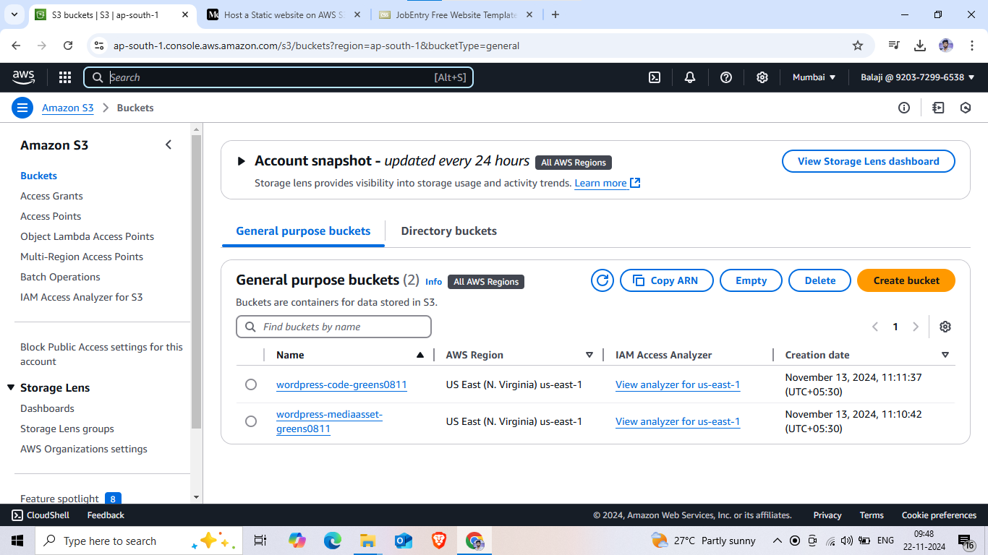

**Bucket name**

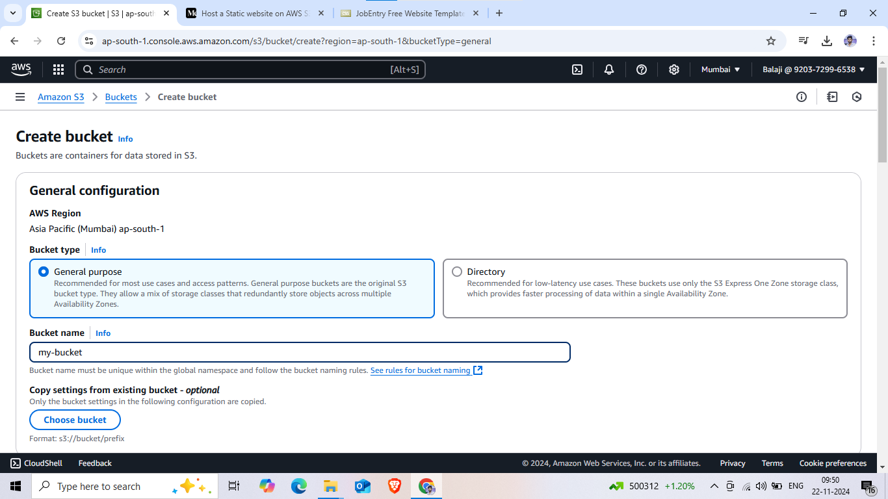

**Enabled ACLs**

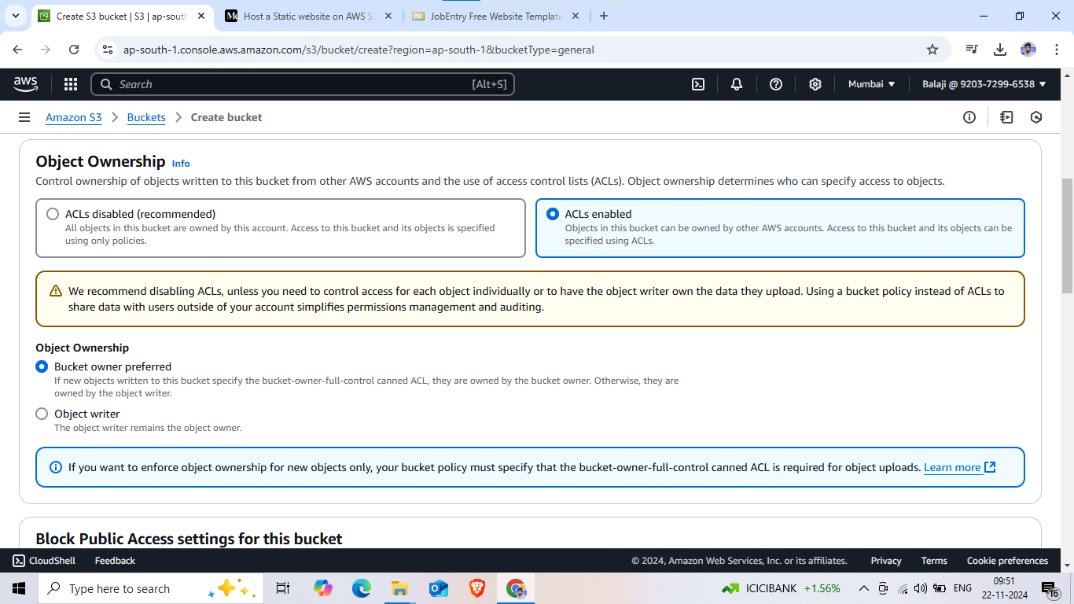

**Unblock access**

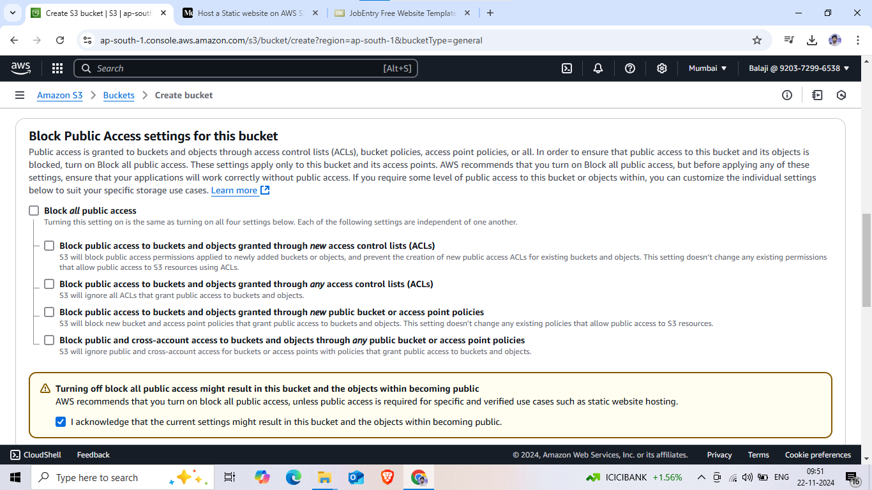

**Create bucket**

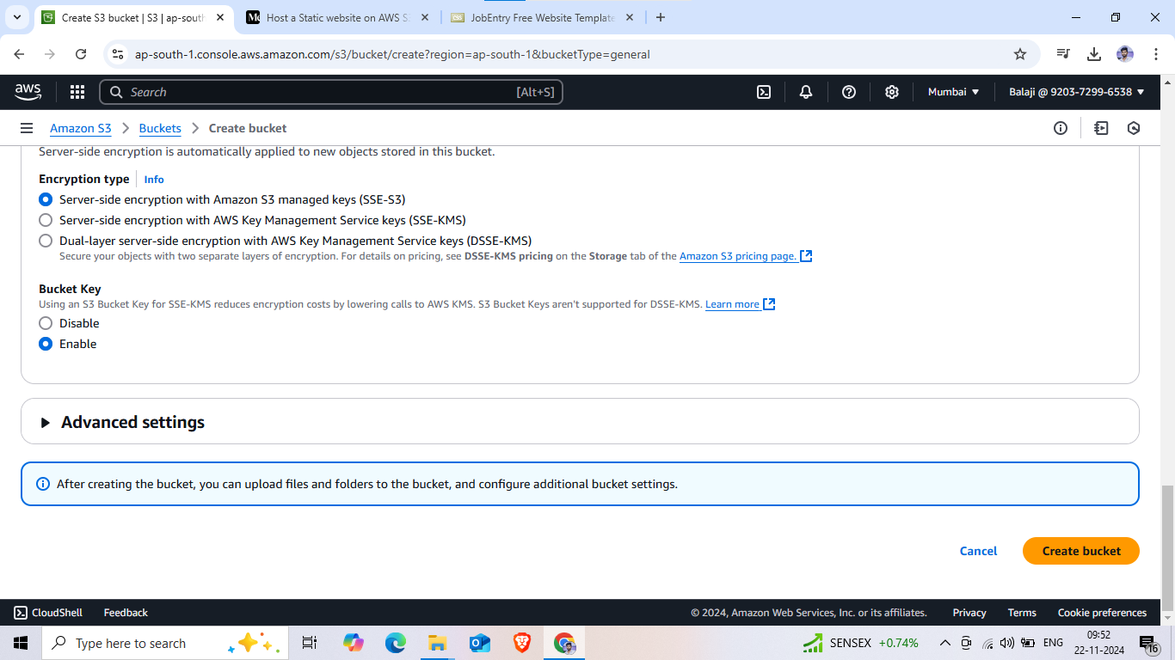

**Open a bucket**

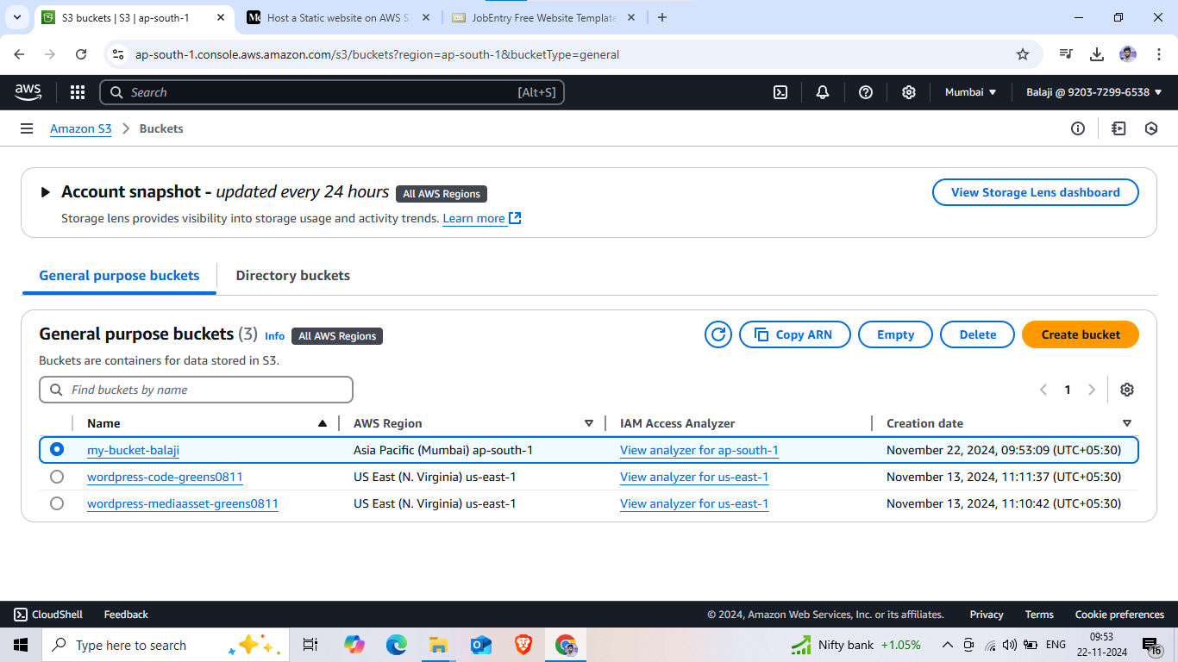

**Click uplode**

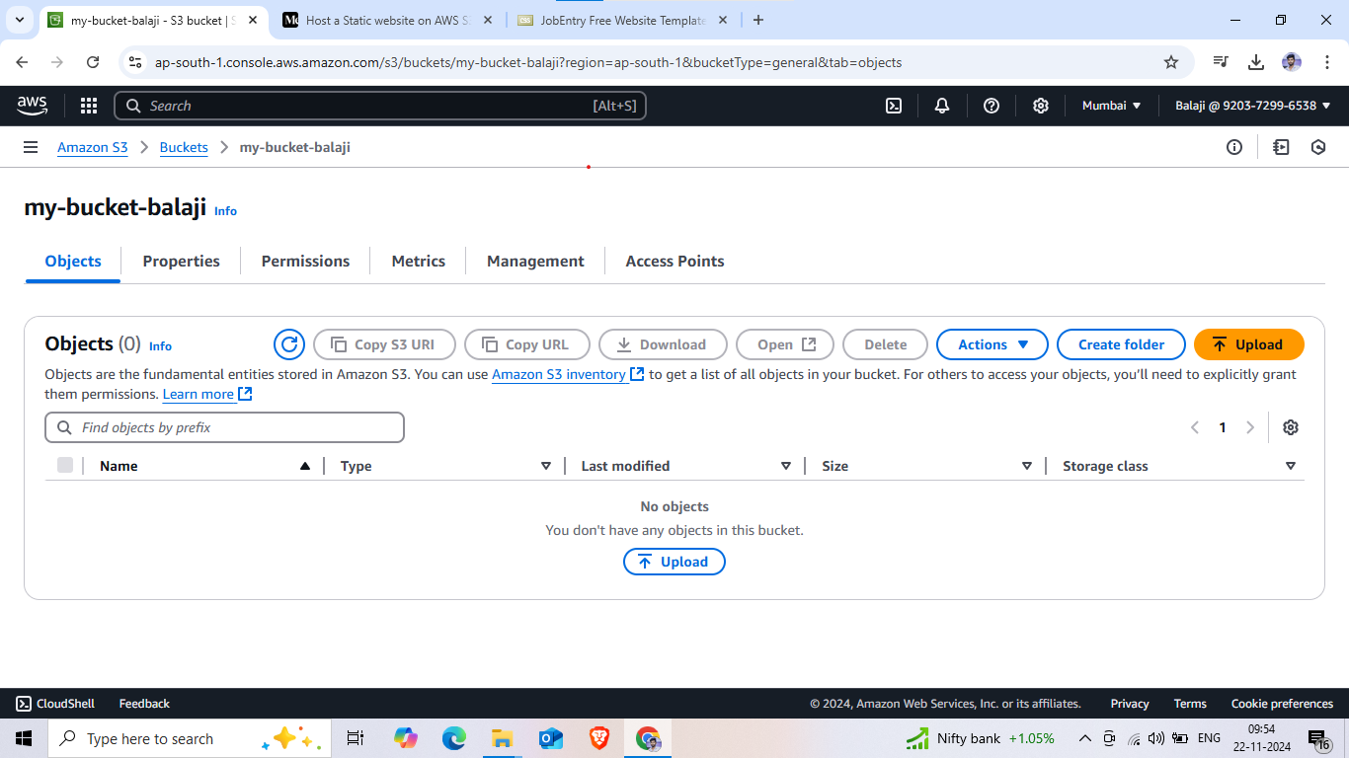

**Add a folder**

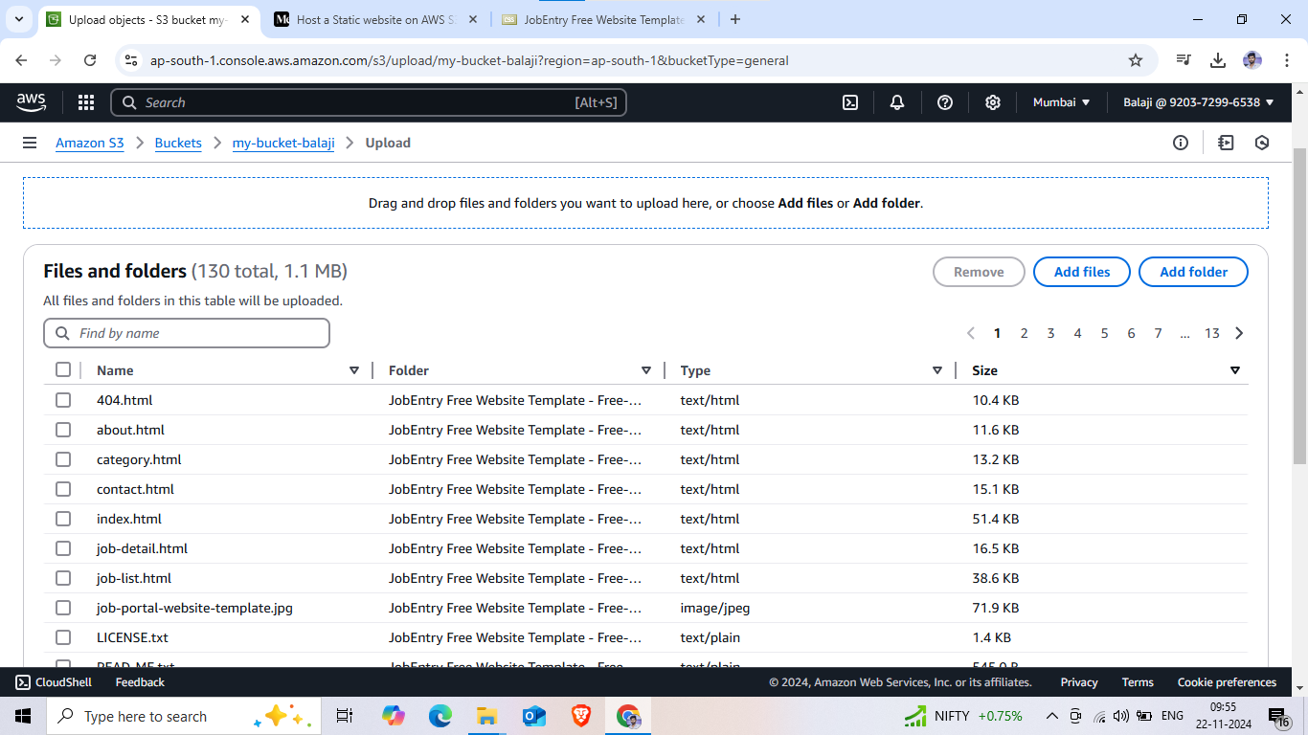

**Grant public-read access**

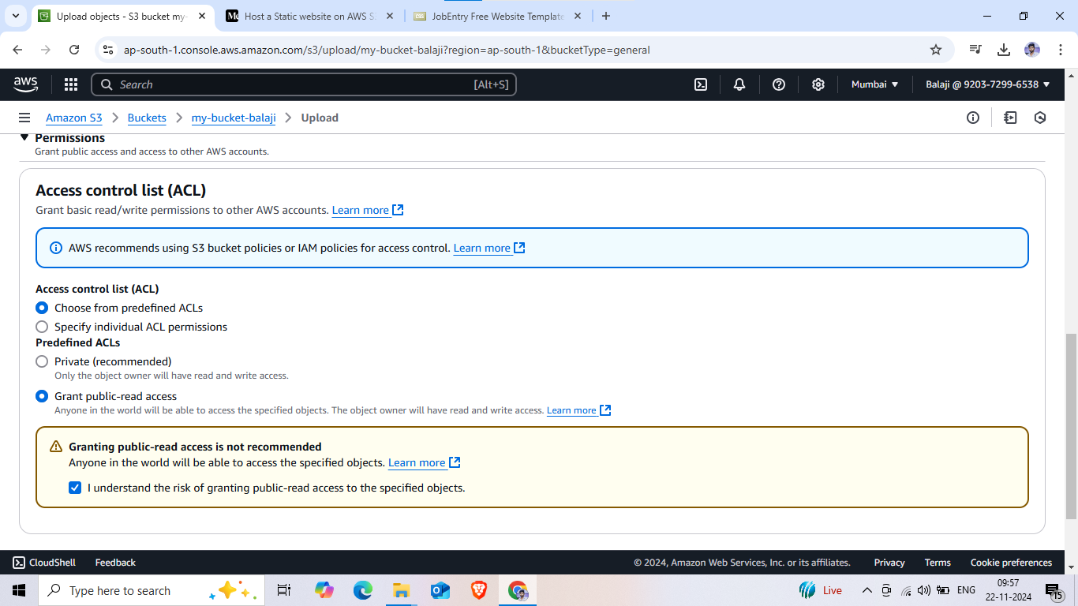

**Upload a bucket**

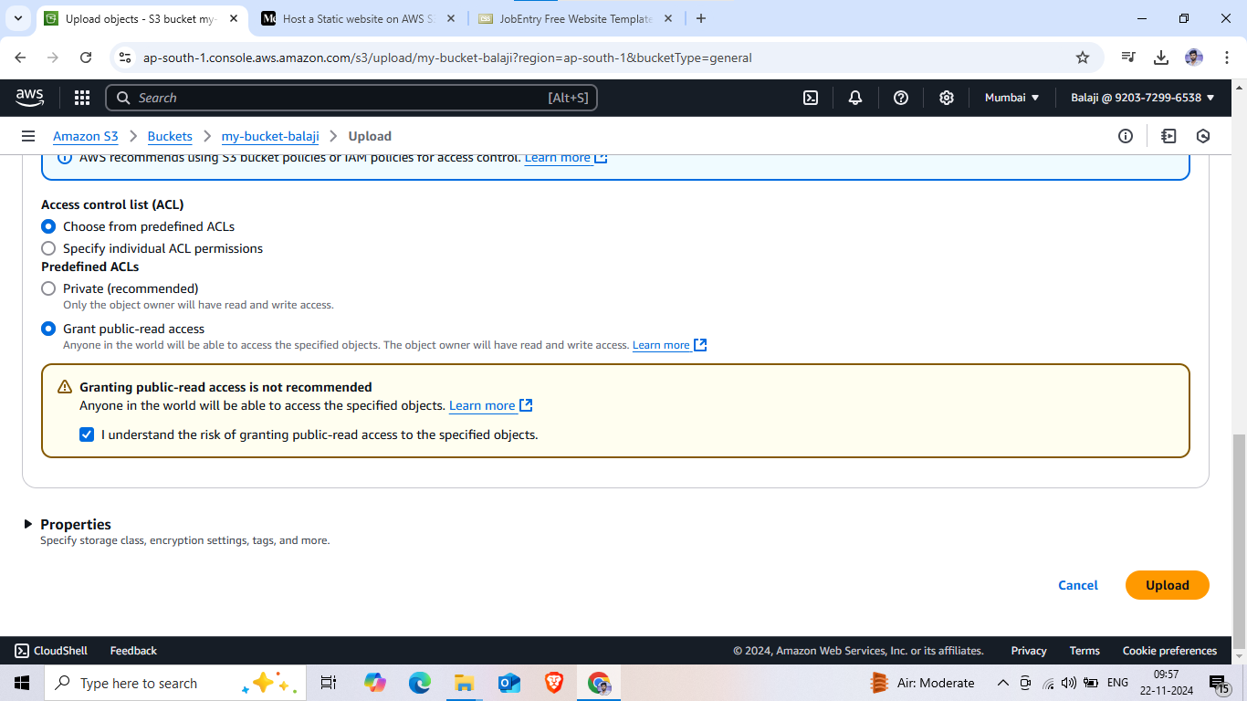

**Click index.html and make public using ALC**

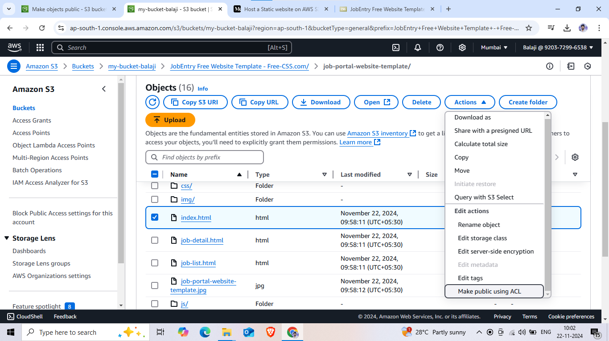

**Enable and host a static website**

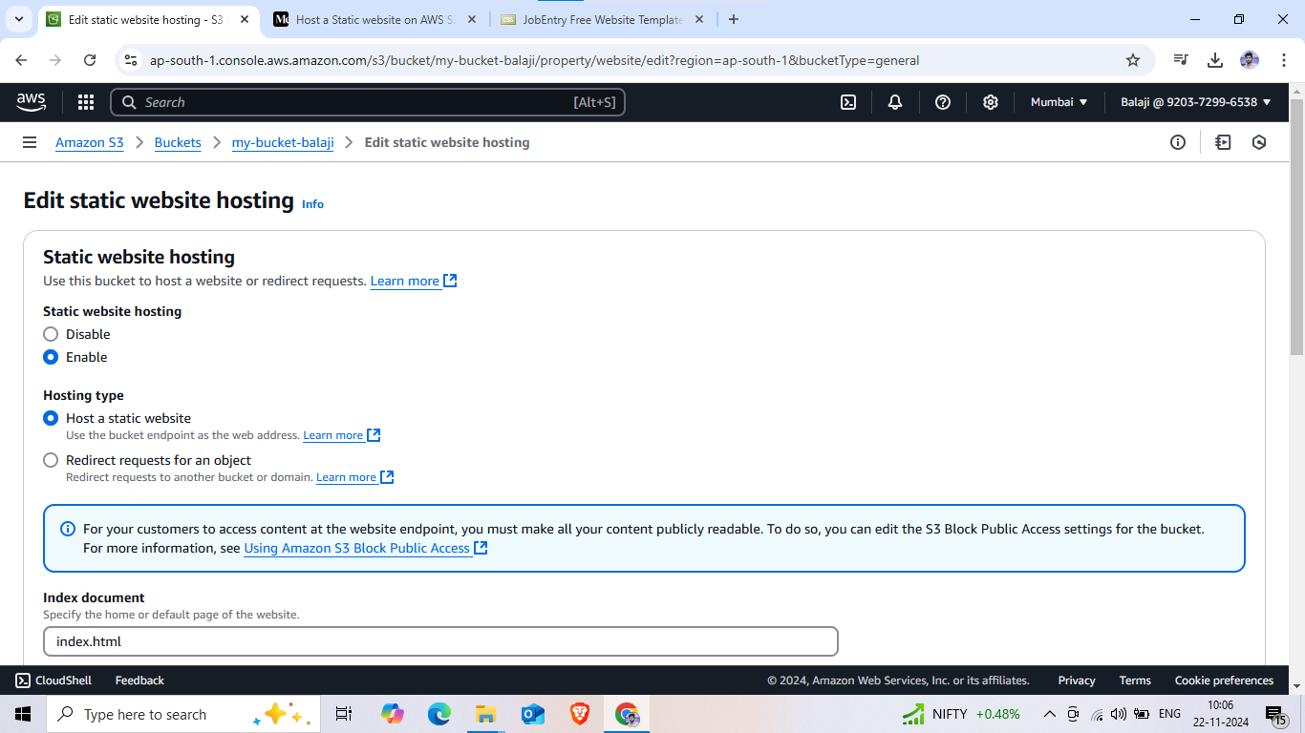

**Open index.html**

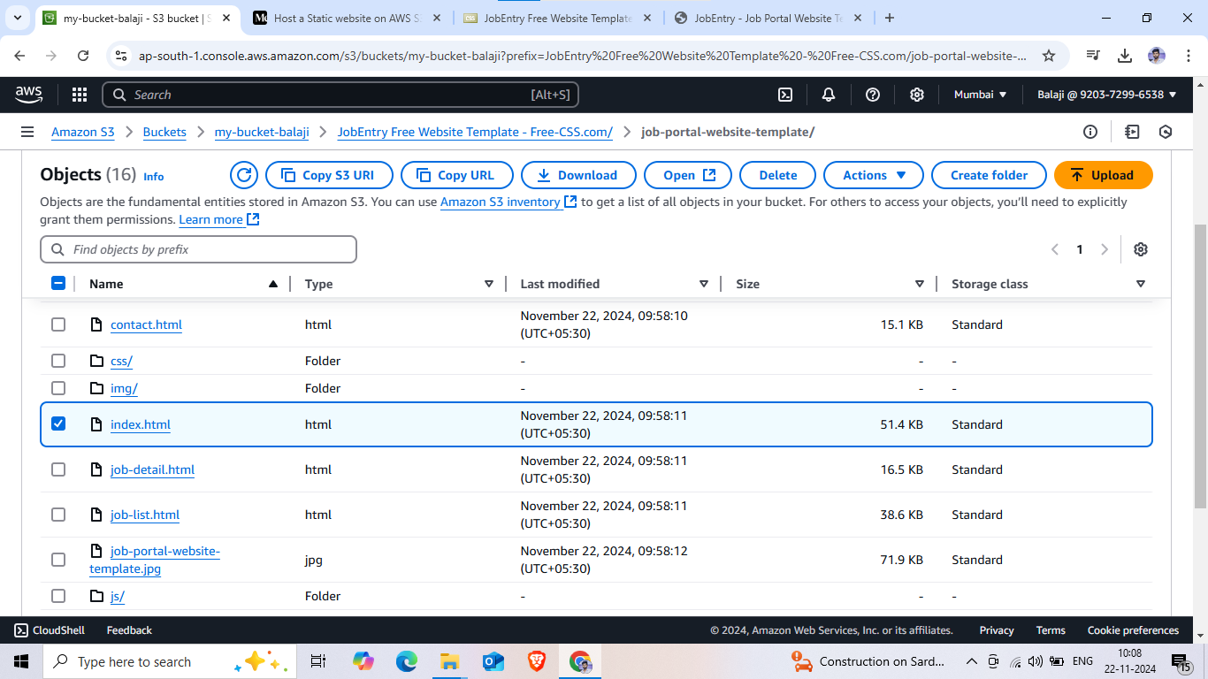

**Object URL copy on past google**

